EXPERIMENT 5(b)

5b.Modelling and simulation of a 4-Layer IoE Architecture (Perception–Network–Middleware–Application) using Node- RED, MQTT and a Cloud Dashboard

1. Objective
- To model and simulate a four-layer Internet of Everything (IoE) architecture using Node-RED and MQTT.
- To understand the functions of the Perception, Network, Middleware, and Application layers.
- To establish communication between simulated sensors and a cloud dashboard using MQTT.
- To monitor sensor data and evaluate system performance based on latency, message delivery, and data processing.
2. Procedure
1. Install the required software: Install Node.js, Node-RED, and the Mosquitto MQTT broker.
2. Configure the MQTT broker: Start Mosquitto and configure MQTT In and MQTT Out nodes in Node-RED to exchange messages using a common topic.
3. Implement the Perception layer: Simulate sensors that generate data such as temperature, humidity, or device status using Inject nodes.
4. Implement the Network layer: Use MQTT to transmit the sensor data from the simulated devices to the processing system through the broker.
5. Implement the Middleware layer: Use Function and Switch nodes in Node-RED to process sensor data, check threshold values, and generate alerts when required.
6. Implement the Application layer: Connect the processed data to a dashboard using suitable dashboard nodes or a cloud dashboard to display sensor readings and device status.
7. Create the complete flow: Connect the nodes in the order Perception → Network → Middleware → Application to demonstrate the four-layer architecture.
8. Test the simulation: Generate different sensor values and verify that the data travels through all four layers and appears correctly on the dashboard.
9. Evaluate performance: Measure message transmission latency, successful message delivery, and data processing performance using the simulation output.

3.Output
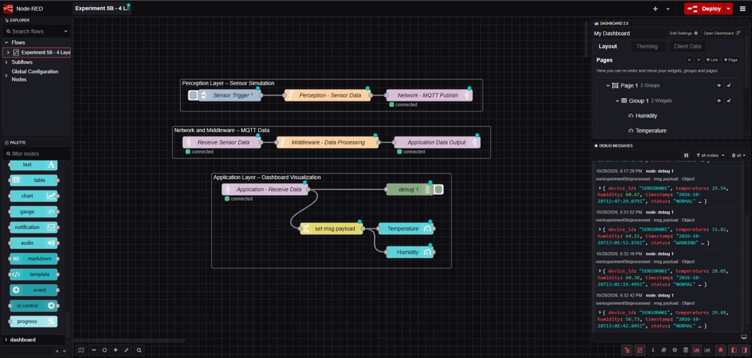
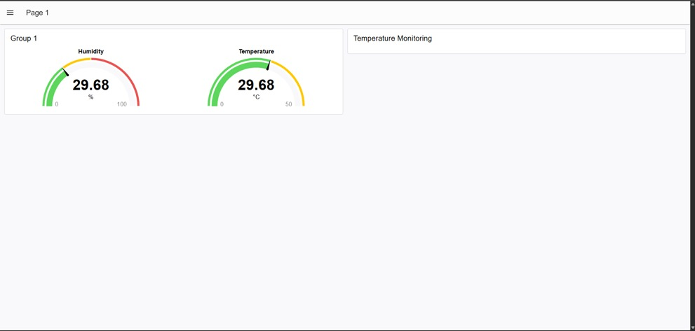

4. Result
The four-layer IoE architecture was modelled and simulated using Node-RED and MQTT. Sensor data generated in the Perception layer was transmitted through the Network layer, processed in the Middleware layer, and displayed in the Application layer using a dashboard. The experiment demonstrated data flow between the four layers, MQTT-based communication, and real-time monitoring of simulated sensor information. System performance can be evaluated using latency, message delivery rate, and processing results obtained during the simulation.

